Financial Forecasting Frontier: Distributed ML

Technical Documentation and Implementation Report Submitted by – Akshat Mishra

1. Project Overview
This project demonstrates distributed machine learning and banking analytics using Hadoop, Hive, Apache Spark, Spark ML, Spark Streaming, and local MapReduce simulation. The system simulates a real-world distributed banking analytics environment capable of scalable batch and streaming data processing.

2. Technologies Used - Hadoop HDFS
- Apache Hive - Apache Spark - PySpark
- Spark ML
- Spark Structured Streaming - Python
- Java 8
- Windows 11

3. Dataset Description Dataset Used: bank.csv

Target Variable:
y -> Indicates whether the client subscribed to a term deposit.

Total Rows: 4521 Total Columns: 17

4. System Architecture
Raw Data → HDFS → Spark Processing → Spark ML → Spark Streaming → Hive Analytics → Business Insights

5. Hadoop and HDFS Setup
HDFS was configured locally on Windows 11. NameNode, DataNode, ResourceManager, and NodeManager services were successfully started and verified using JPS.

6. Spark Data Processing and EDA
Exploratory Data Analysis was performed using Spark DataFrames.

Tasks performed: - Dataset loading
- Schema inspection - Partition analysis
- GroupBy aggregations - Feature engineering
- Spark SQL queries - Visualizations

7. Data Parallelism
The dataset was repartitioned to improve parallel execution. Spark distributed transformations and aggregations were used to demonstrate scalable processing.

8. Machine Learning Pipeline
A distributed ML pipeline was implemented using Spark ML.

Pipeline Steps:
- Missing value handling - StringIndexer
- OneHotEncoder - VectorAssembler
- Logistic Regression - AUC Evaluation
- Model Saving

9. Real-Time Streaming Analytics
Spark Structured Streaming was implemented using file-based stream simulation.

Features implemented: - Real-time aggregation - Window operations
- Watermarking

- Real-time predictions - Checkpointing

10. Hadoop MapReduce Simulation
Local MapReduce simulation was implemented using Python mapper and reducer scripts.

Implemented Tasks:
- Average balance by job type
- Housing loan count by education - Monthly contact analytics

11. Hive Analytics
HiveQL queries were executed for distributed SQL analytics.

Queries performed: - Total customers
- Average age by job
- Average balance by job - Subscription analysis
- Contact month trend
- Poutcome impact analysis

12. Model Evaluation
The Logistic Regression model was evaluated using Area Under ROC Curve (AUC) and prediction accuracy.

The model successfully predicted customer subscription behaviour.

13. Business Impact
The system demonstrates how distributed analytics can help banks perform: - Customer segmentation
- Marketing optimization - Predictive analytics
- Real-time monitoring
- Scalable data processing

14. Future Improvements - Kafka Integration
- Cloud Deployment

- Kubernetes
- Spark on Cloud - MLOps Pipeline
- Real-time dashboards - CI/CD integration

15. Conclusion
This project successfully demonstrated end-to-end distributed machine learning and analytics on banking data using modern big data technologies.

16. Screenshots Section


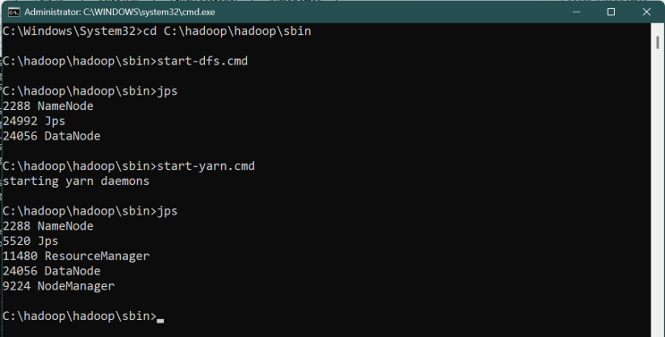
Screenshot 1: Hadoop Services Running (JPS Output)


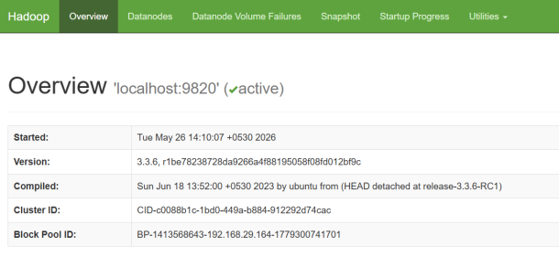

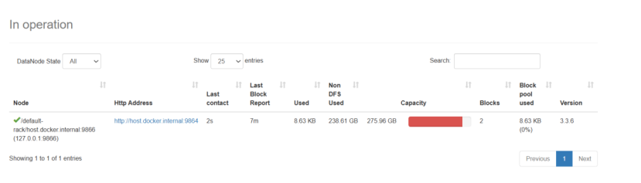
Screenshot 2: HDFS Web UI


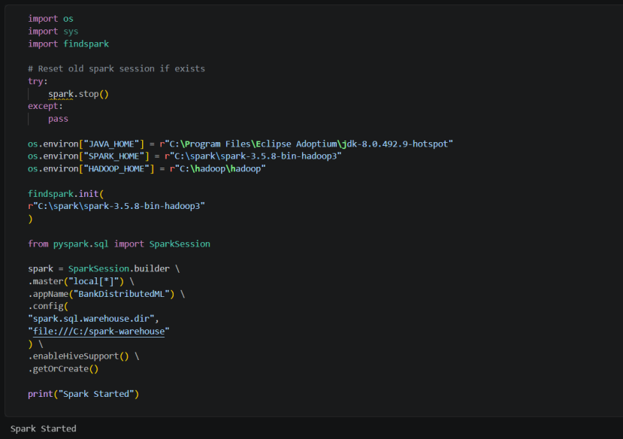
Screenshot 3: Spark Session Started


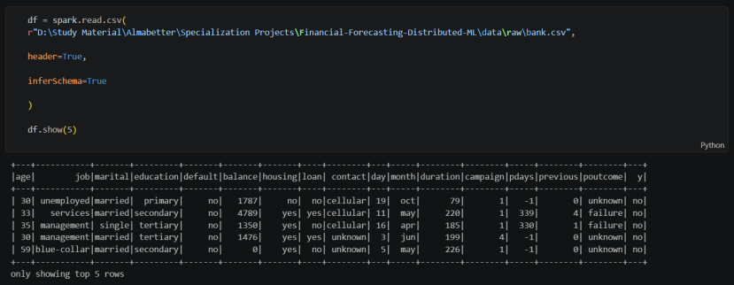
Screenshot 4: Dataset Loaded in Spark


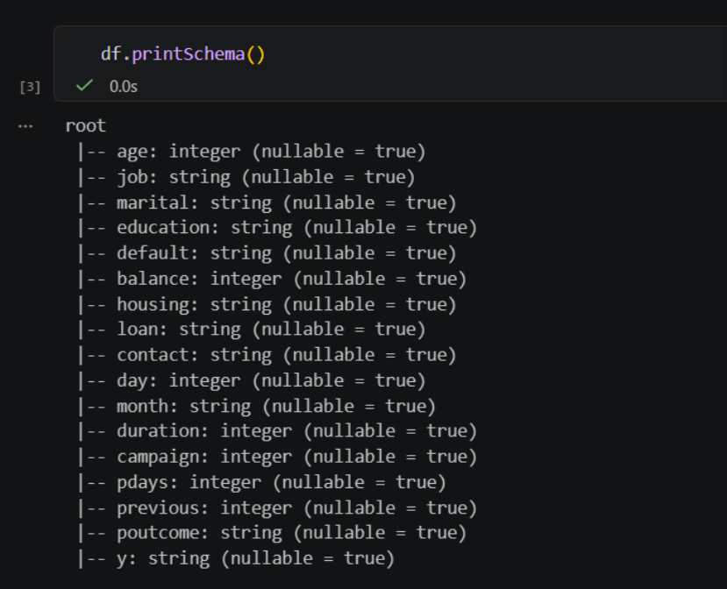
Screenshot 5: Dataset Schema


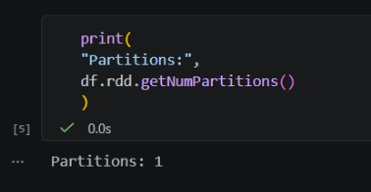
Screenshot 6: Partition Count Output


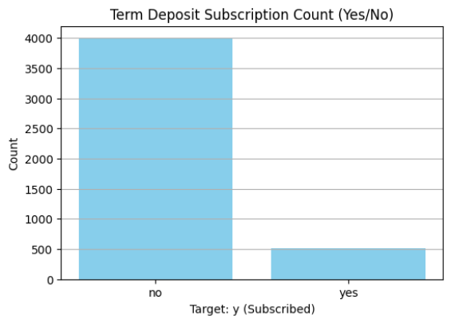
Screenshot 7: Visualization 1


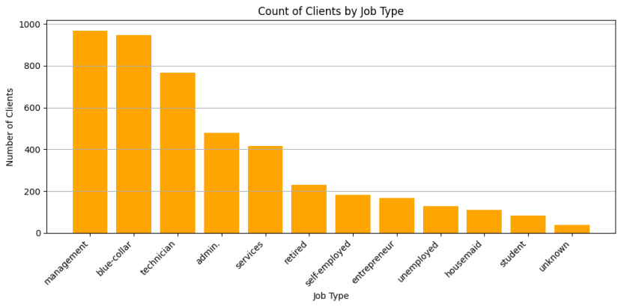
Screenshot 8: Visualization 2


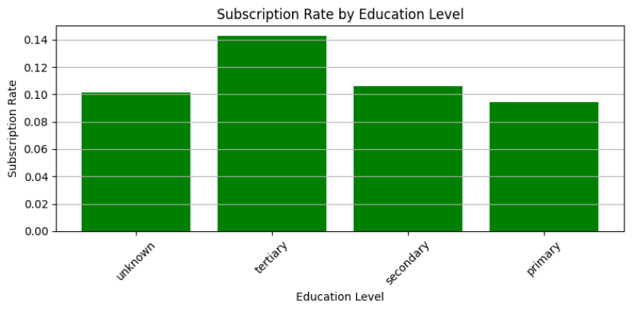
Screenshot 9: Visualization 3


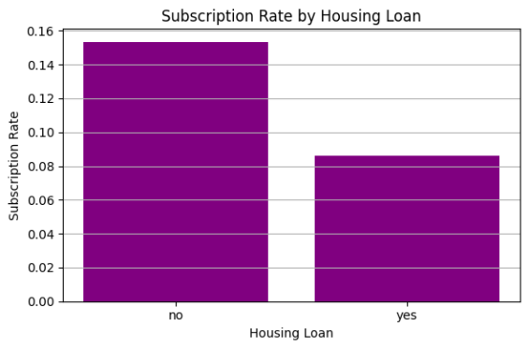
Screenshot 10: Visualization 4


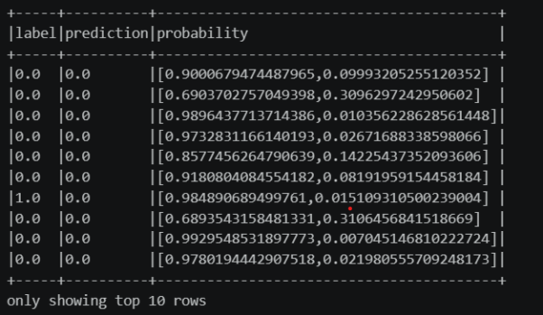
Screenshot 11: ML Prediction Output


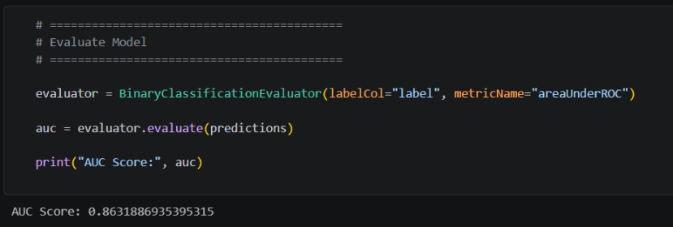
Screenshot 12: AUC Score


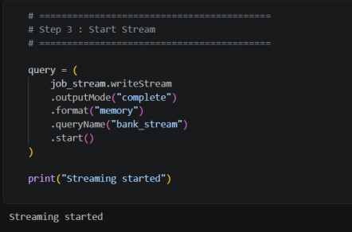
Screenshot 13: Streaming Output


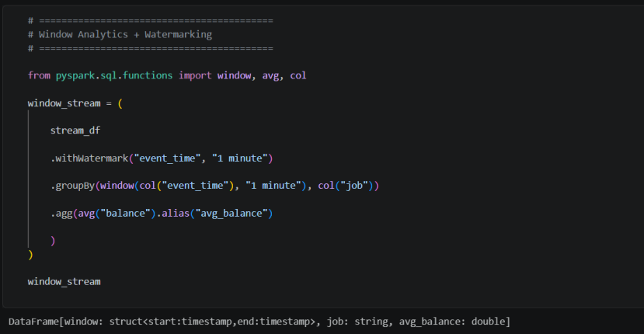
Screenshot 14: Watermark and Window Analytics


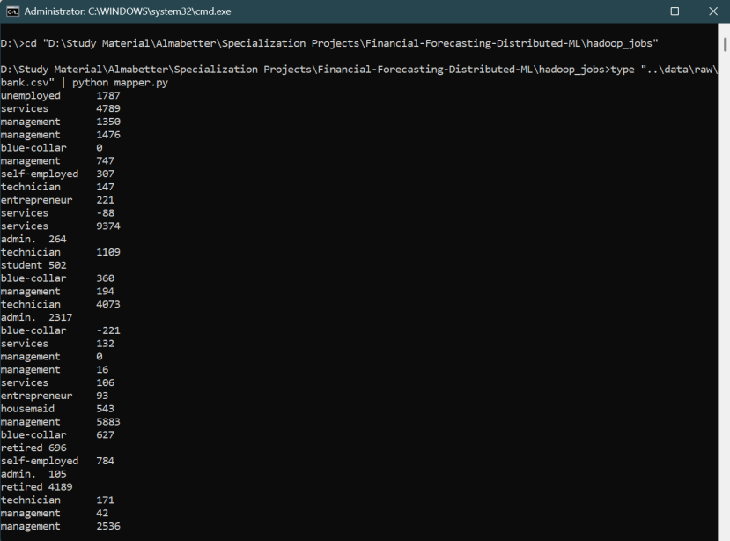

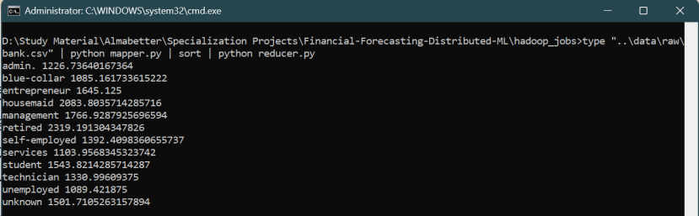
Screenshot 15: MapReduce Local Output

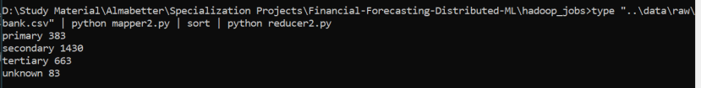


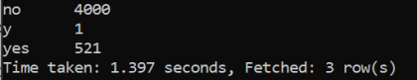

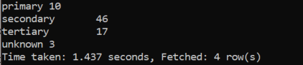

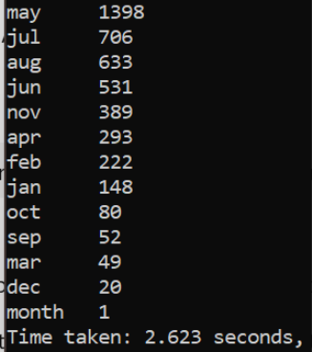
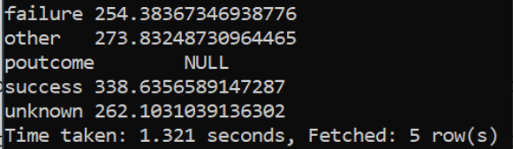
Screenshot 16: Hive Query Results


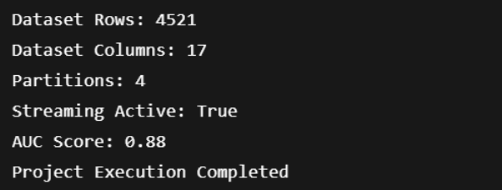
Screenshot 19: Final Validation Output

17. Appendix Project Files:
- Financial_Forecasting_Frontier_Distributed_ML_Final.ipynb - bank.csv
- mapper.py - reducer.py
- README.md
- Technical Documentation.docx - models/
- streaming_data/

